My Travel - Amex
Completing User Profile

Completing your profile and travel preference to book travel through American Express Global Business Travel.

Profile Completion:

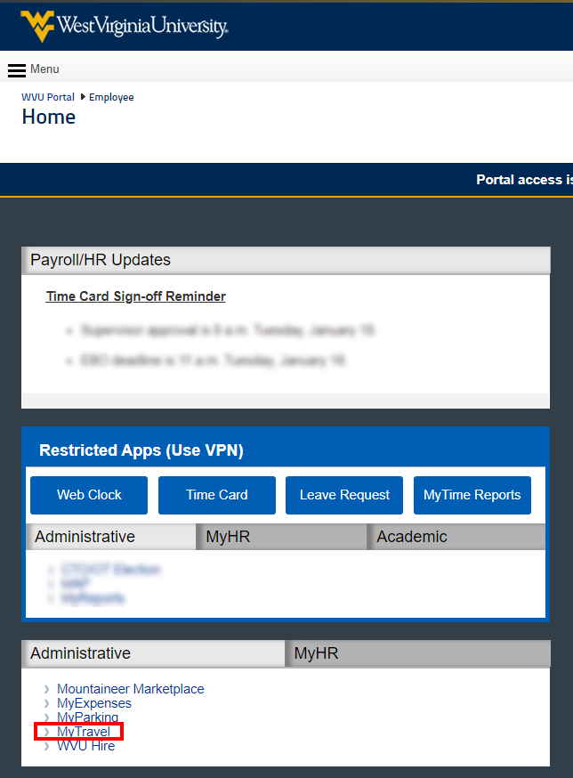
- Using the WVU Portal page, click on MyTravel to access the Amex booking site.

Amex Account / Profile – Page 2

- If you are given a prompt once logged in, click on Go to my profile.

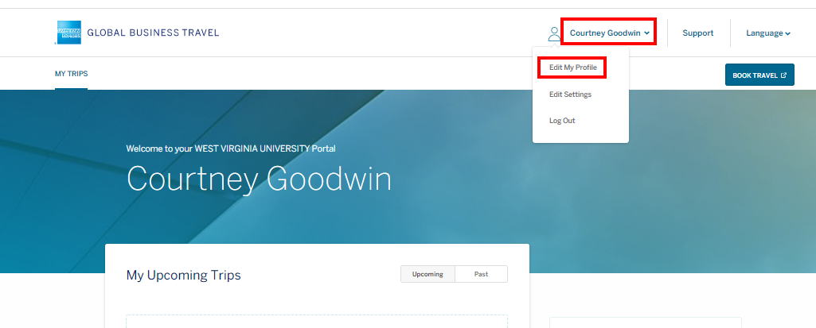
- If you don’t receive a prompt, click on your name in the upper right corner and select Edit My Profile.

Amex Account / Profile – Page 3

- Click through the tabs on the left to navigate through your profile.

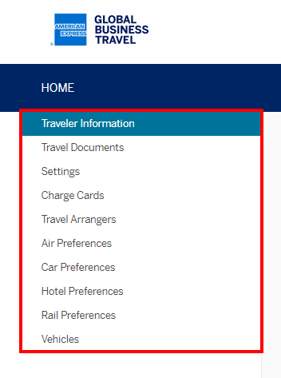

- On the Traveler Information tab, some of your information has been populated for you. Verify the accuracy of the data. If any of this information is inaccurate, please reach out to HR to make the necessary updates.

Additional fields will need manually populated and are noted below in YELLOW.

  - Company Information
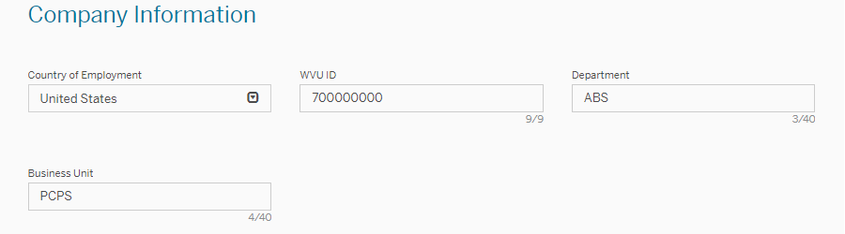

Amex Account / Profile – Page 4

  - Traveler Information
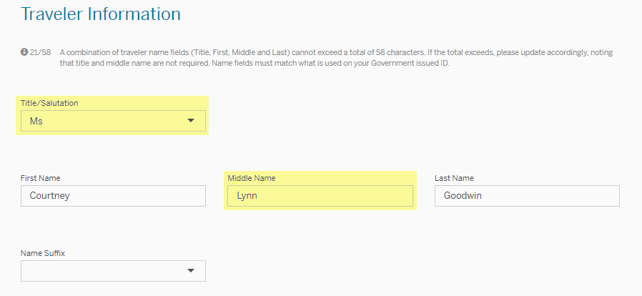
  - Global Identification Requirements
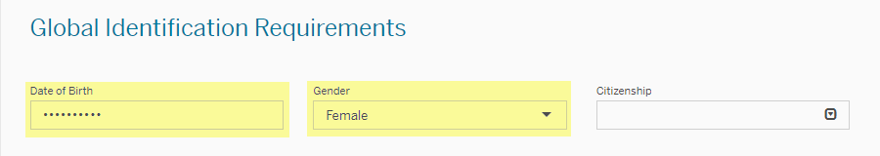

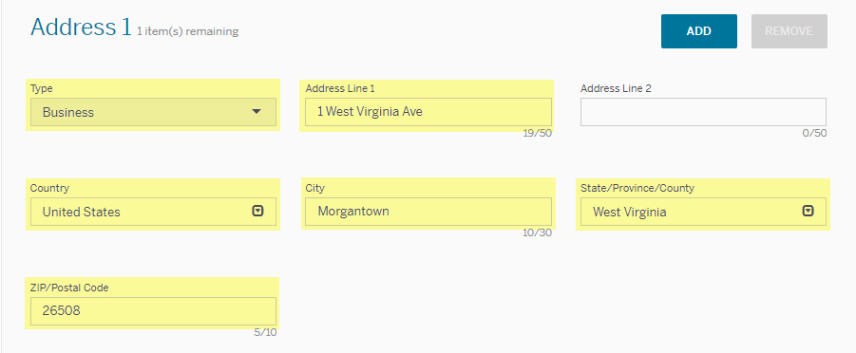
  - Address 1

  - Email Address 1
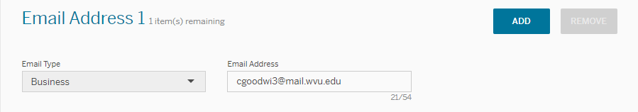

Amex Account / Profile – Page 5

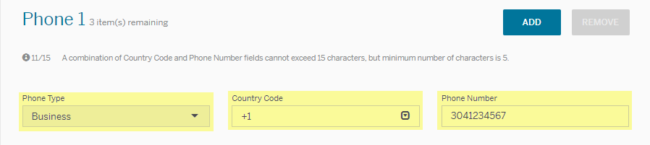
  - Phone 1

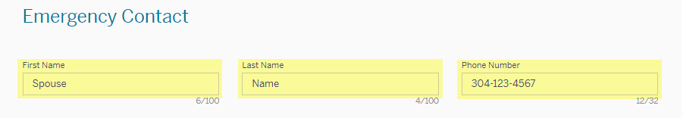
  - Emergency Contact

- Required fields you must completed on the Charge Cards tab are noted below in YELLOW.
  - Charge Card 1
    - For WVU PCard holders, the University strongly encourages the use of PCard as the payment method for air, hotel, and rental car expenses for business travel.
    - For WVU Non-PCard Holders, you would enter in your personal card information.
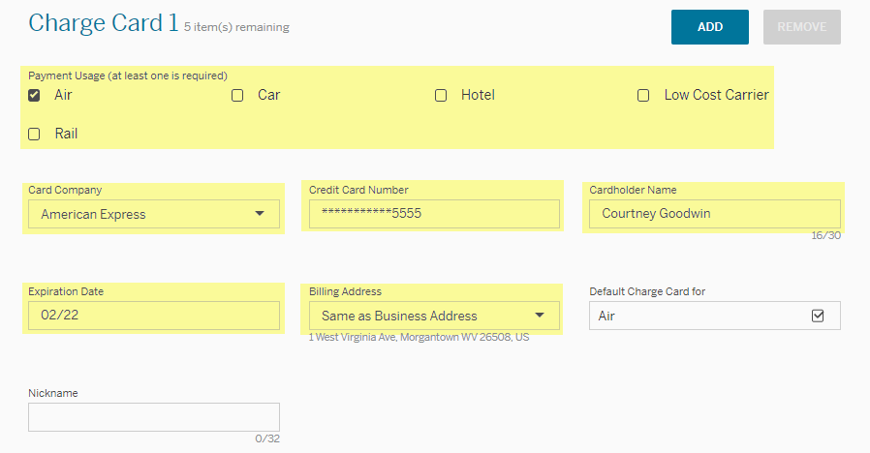

Amex Account / Profile – Page 6

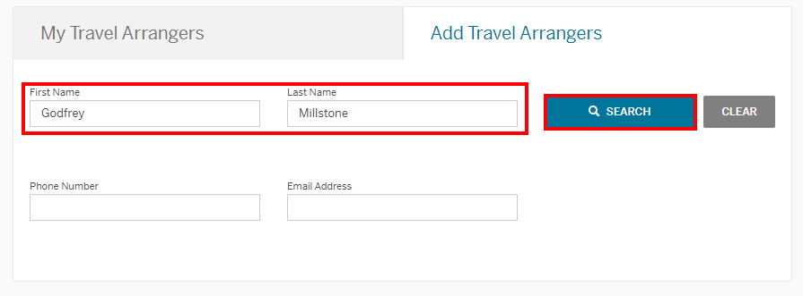
- On the Travel Arrangers tab, you can allow other users to arrange your travel. To add a user, enter their First Name and Last Name and click on Search.

- Select the user and click on Add to allow that person to arrange your travel.
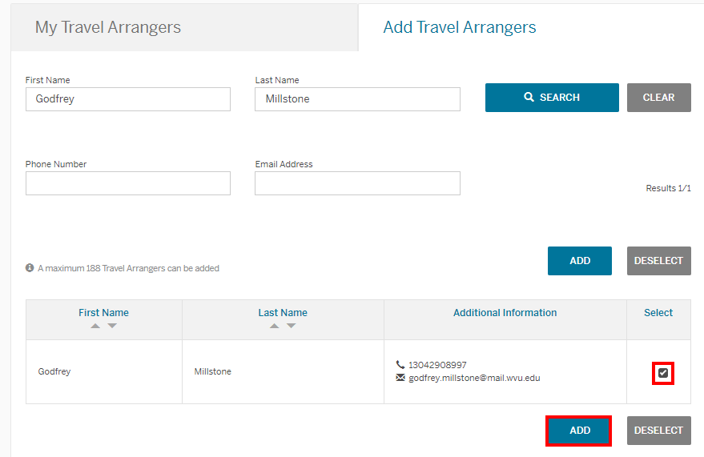

Amex Account / Profile – Page 7

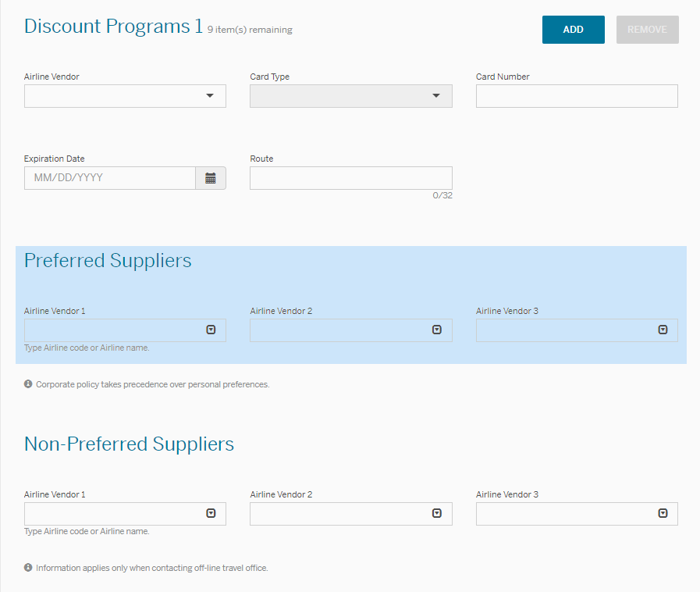
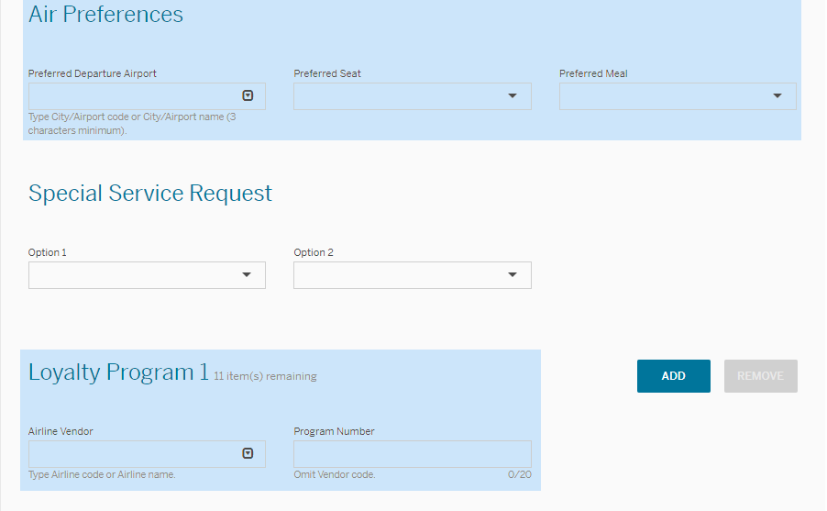
- On the Air Preference tab, you have the option to add personal preferences (preferred departure airport, seat, airlines, etc.) and loyalty program information.

While these aren’t required fields, this will assist with booking your preferred flights while taking advantage of earning points.

Amex Account / Profile – Page 8

- On the Car Preference tab, you have the option to add personal preferences (preferred car category, car type, rental agency, etc.) and loyalty program information.

While these aren’t required fields, this will assist with booking your preferred car rental while taking advantage of earning points.
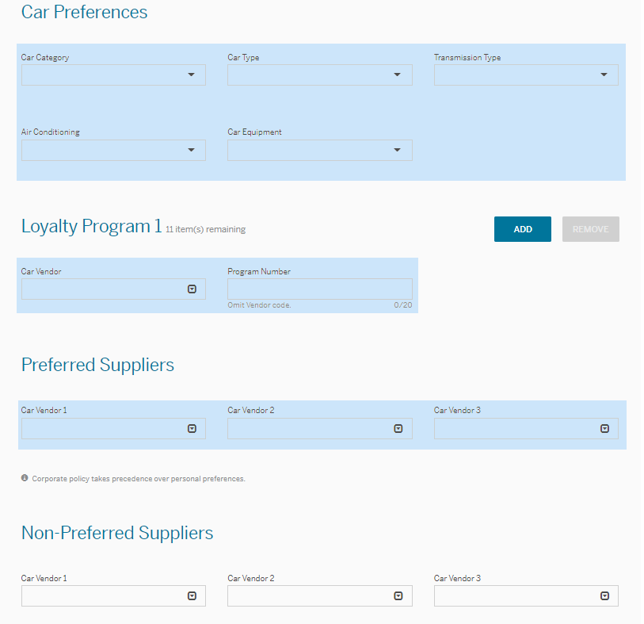

Amex Account / Profile – Page 9

- On the Hotel Preference tab, you have the option to add personal preferences (bed type, hotel brand, etc.) and loyalty program information.

While these aren’t required fields, this will assist with booking your preferred hotels while taking advantage of earning points.

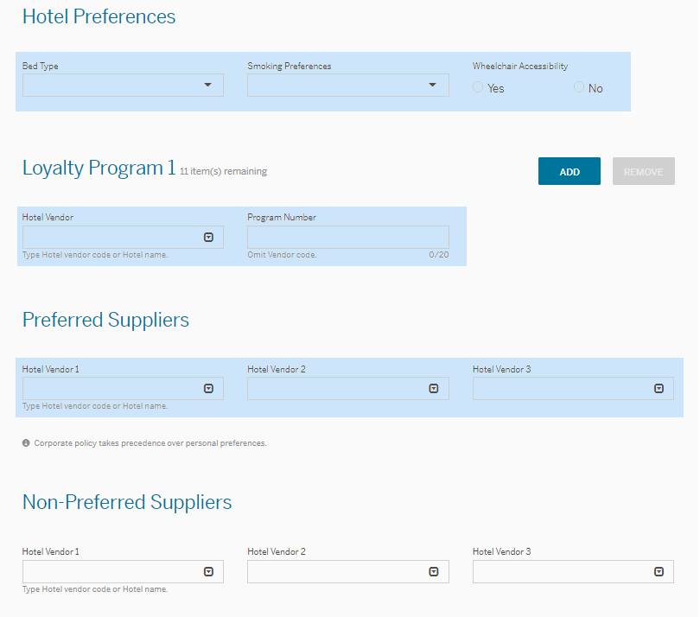

Amex Account / Profile – Page 10

- The remaining tabs can be completed based on your necessary travel needs. Some popular fields are:
  - Settings
      - Preferred Contact Method regarding your trip (i.e., flight delays)
  - Travel Documents
- Passport or VISA information
- Known Traveler Number for TSA pre-screening

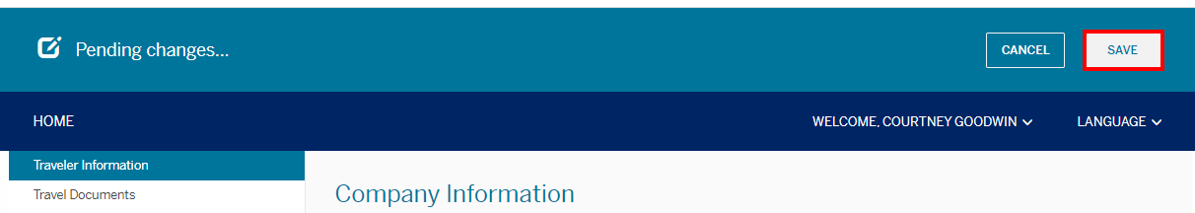
- Once you have completed your profile, click on Save.

Please reach out to pcps@mail.wvu.edu with any questions.

